Data used to generate the Finance Decoder graphs can be found in annual reports produced by nearly all local governments.
 Annual Comprehensive Financial Report (ACFR) follows Generally Accepted Accounting Principles (GAAP) under guidelines set by the Government Accounting Standards Board (GASB) in the United States.

 Annual Financial Report (AFR) follows Public Sector Accounting Standards (PSAS) set by the Public Sector Accounting Board (PSAB) of Canada.

How To Find Your City’s Financial Reports

- Use these terms in your preferred search engine:
  - “[City Name] ACFR” or “[City Name] Canadian AFR”
  - CAFR (Comprehensive Annual Financial Report)
  - annual audit report
  - financial reports
- If search doesn’t get you to your city’s report, find the official government website and use their search function.
- Most entities will have an archive of reports for several years

The report has two sections. You can find what page they start on in your city’s ACFR index.

- The first section to look for is the Management Discussion & Analysis (MD&A). This will contain a series of tables that we will pull 10 numbers from.  - The second section is found in the Notes to the Financial Statements. Specifically, you are looking for the Note on Capital Assets. | 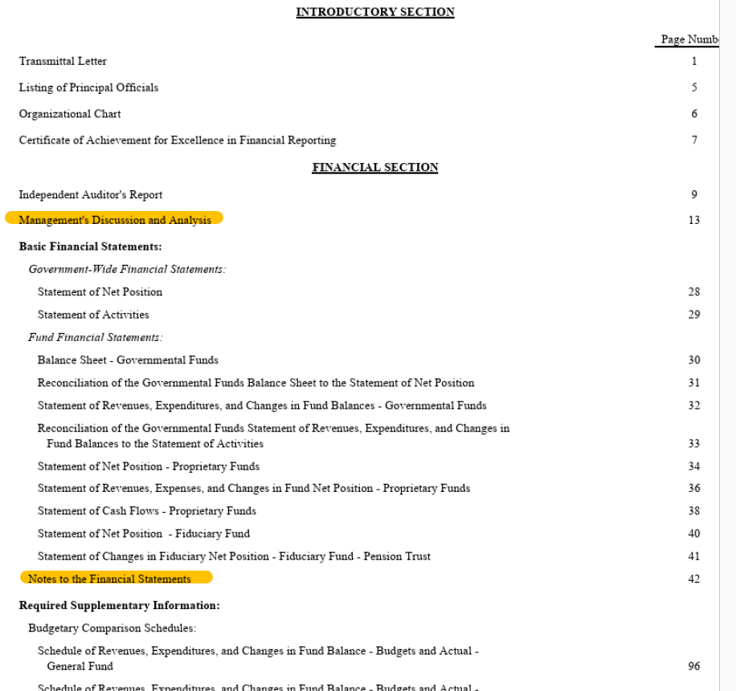

Here you will find the report name and line item we are looking for in the MD&A Section

- In the Net Position report, you will find five line items (or numbers) needed to inform your city’s financial trends. To the left, we have highlighted where you will find these in this table. Their names are:  - Current and Other Assets  - Capital Assets  - Deferred Outflows*  - Total Liabilities  - Deferred Inflows*  - The number you want to pull for each line item is the total of the reported fiscal year (in this case, the farthest right column, under 2024). For example, for Current and Other Assets, under Total 2024 it will be $278,790,983  - *Please Note: GASB did not require separate reporting of Deferred Outflows and Deferred Inflows until 2012, so reports for years prior won’t show those lines. | 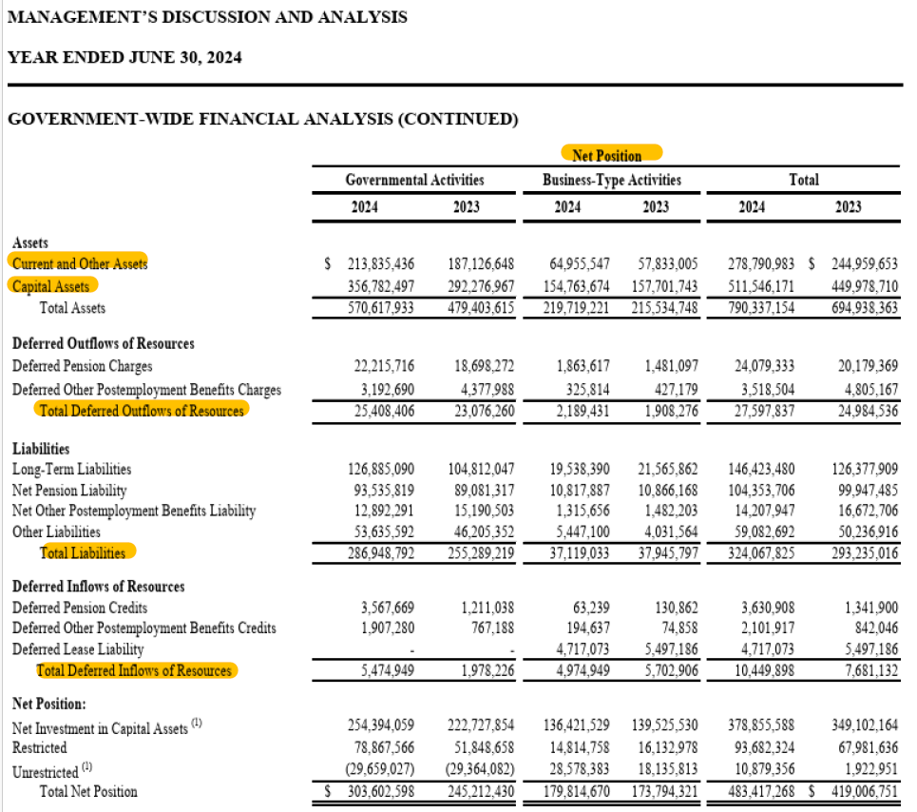

MD&A Section (continued)

- Next, look for the report titled Changes in Net Position (see left) so you can pull the following four line items from these graphs. Similar to our Net Position report, pull the total of these line items for the reported fiscal year.  - Total Revenues  - Operating Grants and Contributions  - Capital Grants and Contributions  - Interest Charges (Debt Service) | 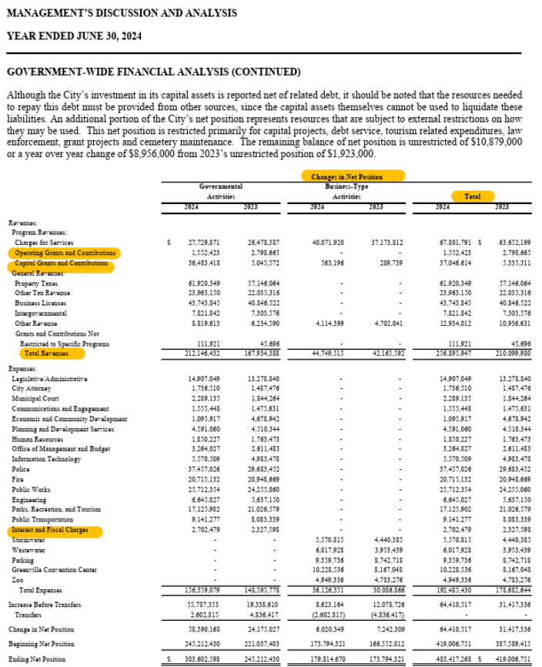

MD&A Section (continued)

- The final report you will need from the MD&A section is the Capital Assets (net of depreciation) report. Here, the line item needed is the total for the reported fiscal year. In this case, in 2024, this would be $511,546,171.  - Total  - Tip: There is usually a footnote to this report indicating where in the Notes section the Capital Assets details can be found for the next step | 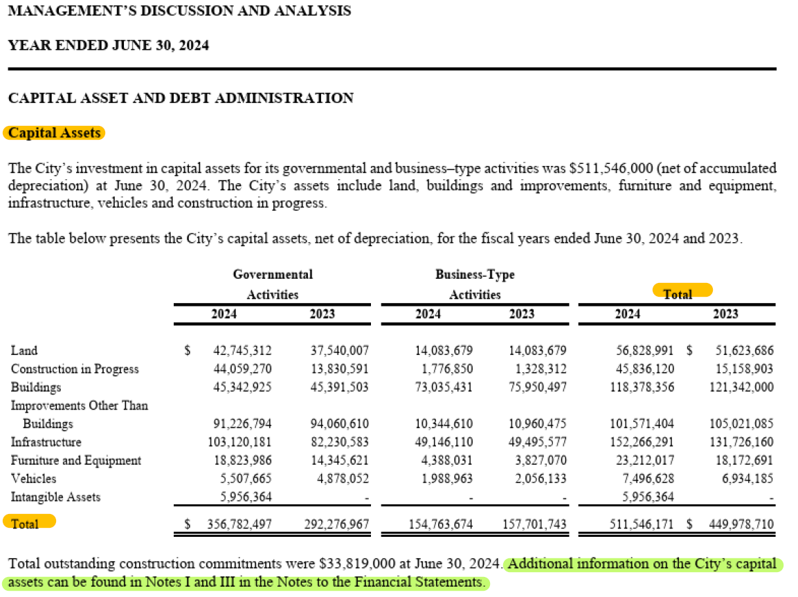

Here you will find the report name and line item we are looking for in the Notes to the Financial Statements

- The sequence and numbering of ‘Notes to the Financial Statements’ will vary across entities and even year-to-year for the same entity. To find this information more easily:
- First navigate to the section labeled ‘Notes to the Financial Statements’
- Next, search for where this section mentions ‘Capital Assets’ and go to the associated page for this information.
- Here you will find two tables. These are called the:
  - Governmental Activities
  - Business-Type Activities
  - Note: Some organizations will report component Business-Type Activities separately; be sure to add them all

- From each report we will pull two line items (In total we will have 4 line items pulled from these two tables):
  - The ending balance for Total Capital Assets, Not Being Depreciated
  - And the ending balance for Total Capital Assets, Being Depreciated
  - Tip: Be sure to use the total cost of capital assets prior to depreciation, not the Net shown at the bottom of the report
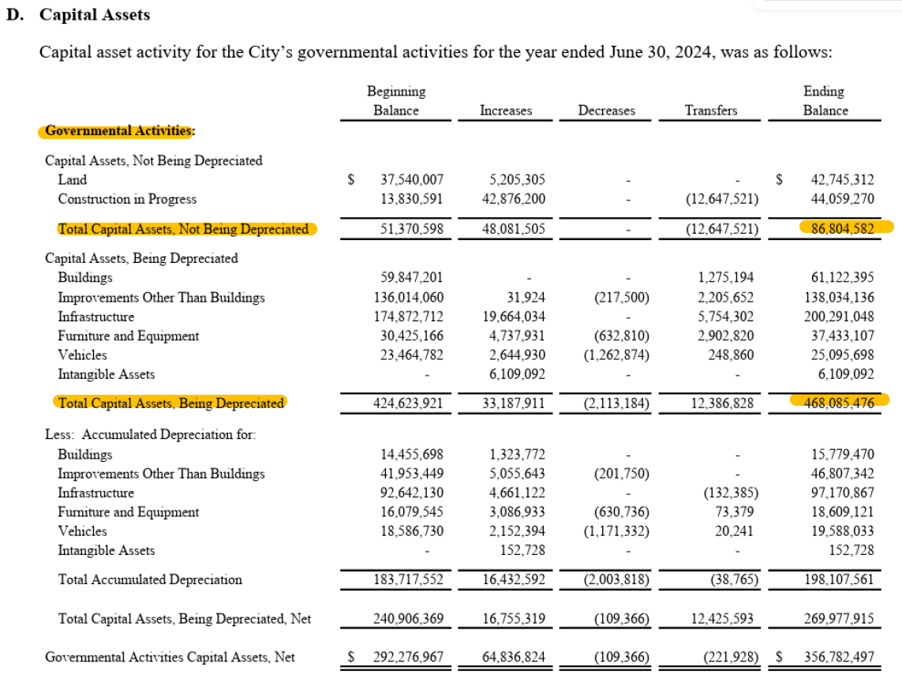 | 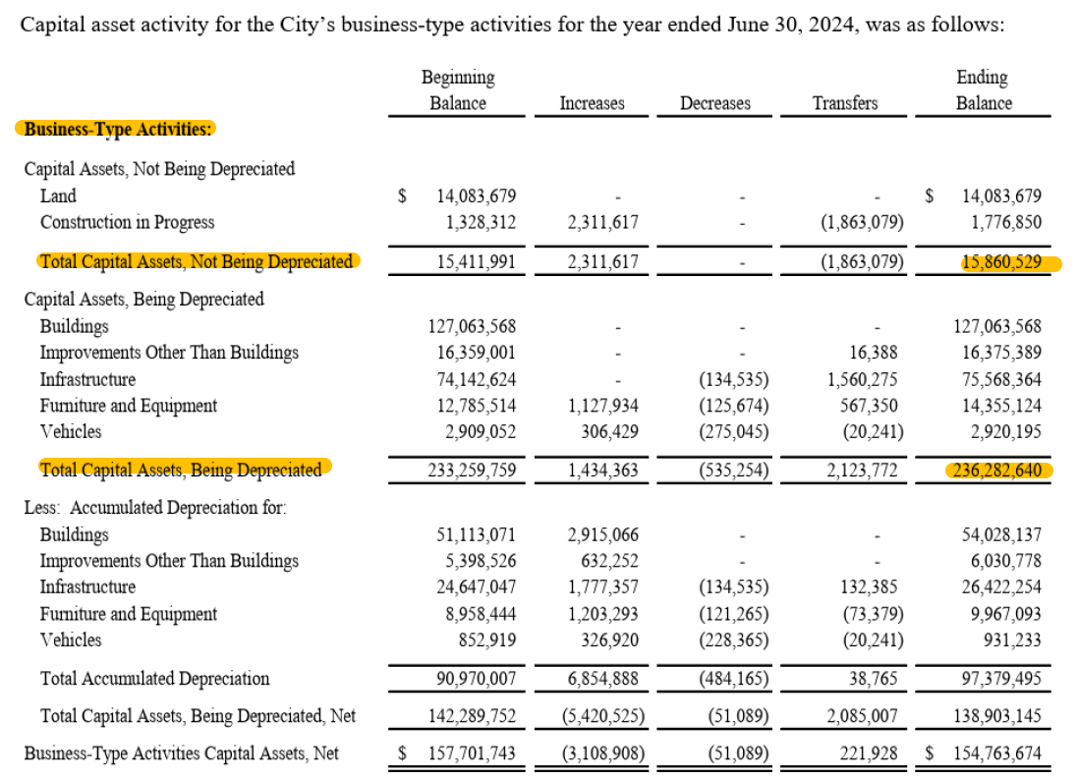

Tips and Pitfalls to look out for:

- How is the information in these tables displayed?
  - The reports show current and prior year for comparison but the prior year (highlighted in green) is almost always stated to the right of the current year (highlighted in yellow).
  - Column order is usually current year, then prior year, which is counter to the sequential order of years in the worksheet
  - Please be mindful of the year and column when entering data so your trend lines most accurately reflect your city’s financial information.

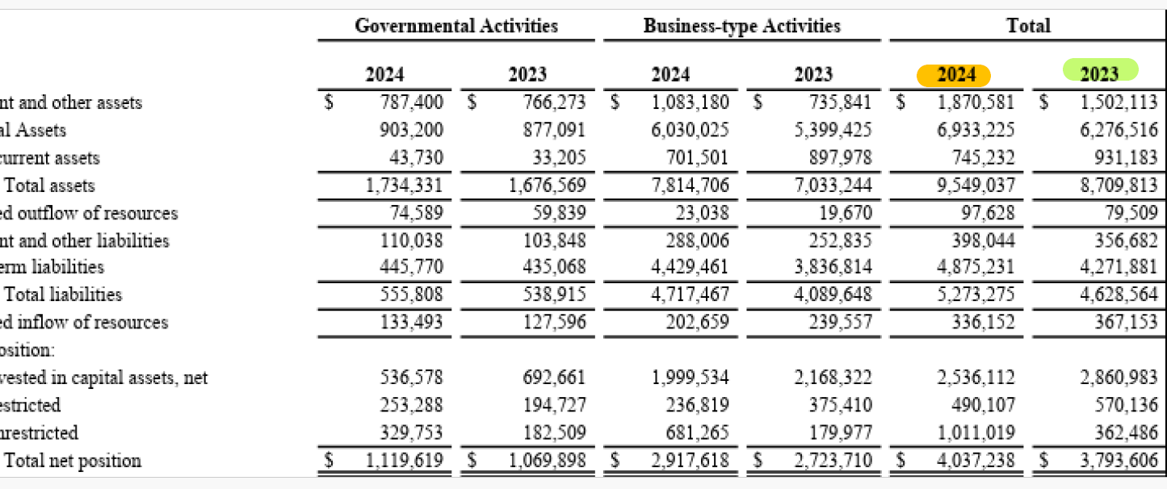

- Why do some of my cities' tables have such small/ large quantities?
  - Many entities will round to thousands or even millions in different tables on some of the reports.
  - Usually, rounding will be noted in the title of the table you are working with (see image below).
  - Be aware of differences in rounding across sections and tables and make sure the numbers you input for each line item reflect the rounding your city is using.
  - For example, often the Capital Assets detail in the Notes section is not rounded, even when reports in the MD&A section are. You may want to convert non-rounded numbers when entering them into the worksheet. (enter $1,000,000 as $1,000 when rounding to thousands)
  - Tip: So that data is presented correctly in graphs, please be sure to select the rounding in cell G3 on the Input sheet.
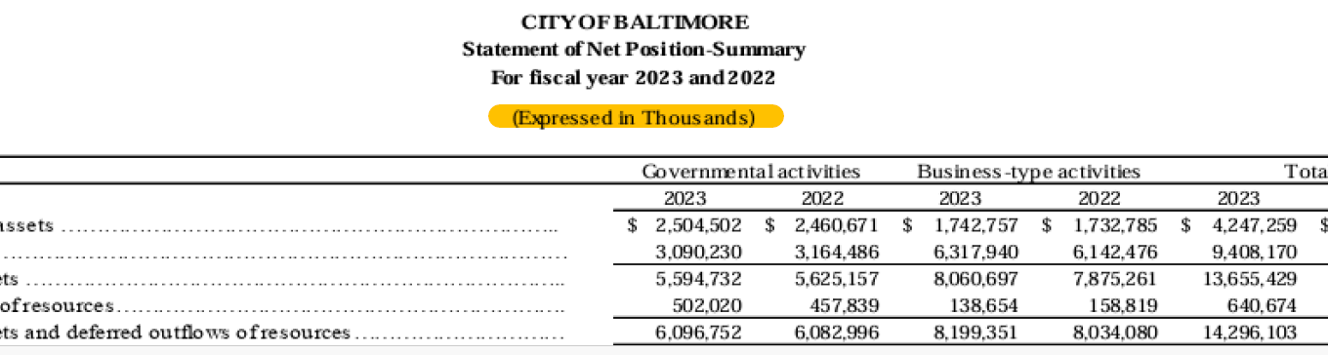

- What is the best year to start compiling this information for the graphs.
  - It is best to work backwards, gathering data from the most current year first. There are often adjustments made to the prior year data that are reflected in the most recent report and will help you more accurately reflect your city’s financial position.
  - Start with the most recent available year and enter both current and prior year data
    - From 2024 report, enter data for 2024 and 2023
    - From 2023 report, enter data for 2022
    - On the Capital Assets reports in the Notes section, the Ending Balance column is the current year, and the Beginning Balance column is the prior year
  - Tip: Prior year adjustments are not likely to be materially significant, but it’s still recommended to use the most recent data

Below is an example of Business-Type Activities shown separately (Water & Kansas City Airport on this page followed by Sewer on another page). In order to find the Total Capital Assets not being depreciated for the Business-type Activities in this case, we must sum the total balance for April 30th, 2024 for Water, Kansas City Airport and Sewer). To find the Total capital assets that are depreciable, sum the total balance for April 30th, 2024 for Water, Kansas City Airport and Sewer as well.
